1. Change the URL from ATPfinals - to barclaysatpworldtourfinals.

***JUDIT****: At this stage this change is quite risky specially considering the amount of links and the e-commerce. I really do not recommend this but take under consideration for next ATP.*  
2. On the page below amend the text to say ‘Collect at The O2’ instead of O2 Arena

***JUDIT****: We will apply this change and will be ready next week*  
  
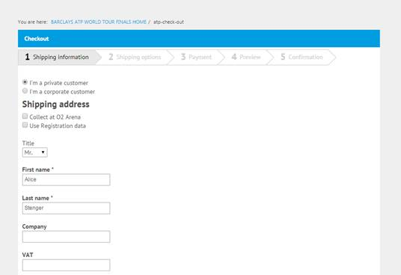

1. We need to include on the page that pricing exludes VAT. Please advise where would be the easiest to show this. Alternatively, please add it as indicated below in red:

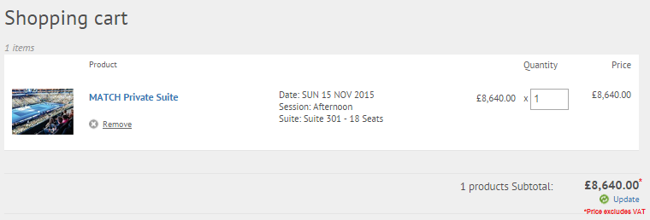

***JUDIT****: We will apply this change and will be ready next week*

1. On the page below – change tax to ‘VAT’.

***JUDIT****: We will try to apply it although I’m not 100% sure we will be able to change it*

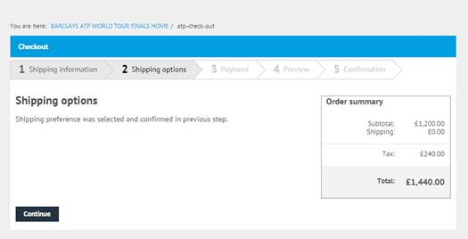

1. Please add the following at the bottom of the page:

Barclays ATP World Tour Finals photography courtesy of Red Photographic, Ella Ling and Getty Images.

***JUDIT****: Done*

